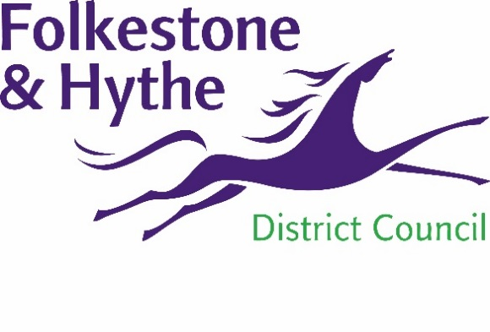
NEWS RELEASE

2 August 2021

LATEST PHASE TO ENSURE SAFE REPTILE RELOCATION

Work to safely relocate reptiles from Princes Parade to a suitable habitat within the Royal Military Canal corridor in Hythe is to start this week.
Fencing will be fitted along the western, northern and eastern boundaries of the existing habitat areas to sensitively trap reptiles that currently inhabit the site.
Once captured by suitably experienced ecologists, they will then be taken to the nearby suitable land. All of the work will be in line with the appropriate guidelines and overseen by experts.
The project will see at least a 50% increase in suitable reptile habitat in the area:
- 0.7 hectares will be located on nearby land – providing foraging, sheltering, basking, refuge and hibernation opportunities for slow worm, common lizard and grass snake.
- A further 1.4 hectares will be delivered on site during the first phase of the scheme.

These works are required to be completed prior to the construction phase – which will start next year and deliver accessible leisure facilities for all.
A Folkestone & Hythe District Council spokesperson said: “The new and enhanced reptile habitats will connect onto a wider network of suitable habitat within the Royal Military Canal corridor.
“They will be managed to ensure they continue to provide foraging, shelter, basking and hibernation opportunities for reptiles long after the project has been completed.”
The capturing work will take place for at least 30 days and will not stop until there has been five clear days when no reptiles have been caught.
Residents are asked not to enter the site as this may inadvertently have a negative impact on the project’s determination to safeguard the local reptile and animal population.
Some foliage will be trimmed to allow the fencing – which stands at 0.5m – to be installed. Any noise generated by equipment is highly unlikely to cause any nuisance to nearby properties.
The Princes Parade scheme is transforming a former municipal waste tip into an accessible area which can be enjoyed by all – facilities include a large public park, enhanced indoor leisure facilities and a vehicle-free promenade.
At the same time – and at the heart of the project – work is being carried out to safeguard the site’s key ecological features and introduce new habitat to encourage native species to flourish.
For more information, please visit folkestone-hythe.gov.uk/princesparade
ENDS
Notes to Editors:
For more information, please email communications@folkestone-hythe.gov.uk

Follow us on Facebook: @FolkestoneandHytheDC
Follow us on Twitter: @fstonehythedc
Follow us on Instagram: @folkestonehythedc
Follow us on LinkedIn: Folkestone & Hythe District Council

